**Practical-12☺**

**Display 1 to 50 book IDs sequentially. Mark every 5th book as a "Special Edition". Write a program to generate this catalog , ensuring it displays each book ID on a new line and highlights special editions with a clear note next to their ID.**

**Code:**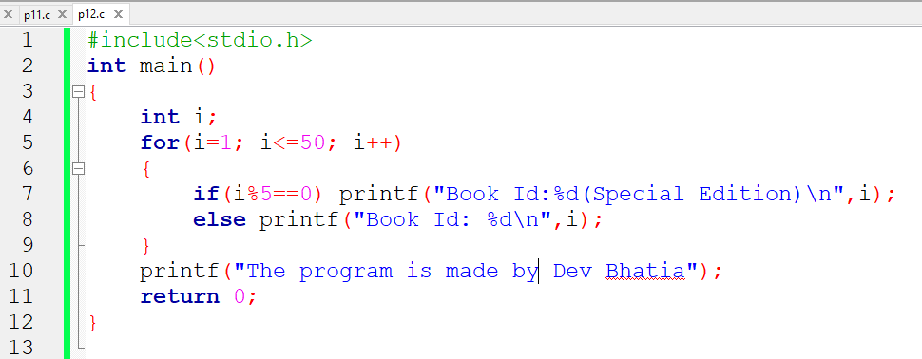

**Output:**

